

**Introduction**

A Base Transcivier Station (BTS) Is a place of network equipment that facilitates wireless communication between a device and network

There are 3 places that we analysis :

-Poligon,Simpang Angkatan 45,Demang

Which has 3 service cells that we analysis :

-Telkomsel

Application that we used :

Pengantar Telekomunikasi

Analysis A Ease Trasncivier Station

For Client In Unsri

1.Muhammad Rafi Wardhana (09011382025140)

2.Lambang Rio Romayu (09011382025097)

3.Muhammad Kabir Akmal (09011382025126)

4.Muhammad Iqbal Nur’alim (09011382025147)

5.Radhini Yasmin ( 09011382025149)

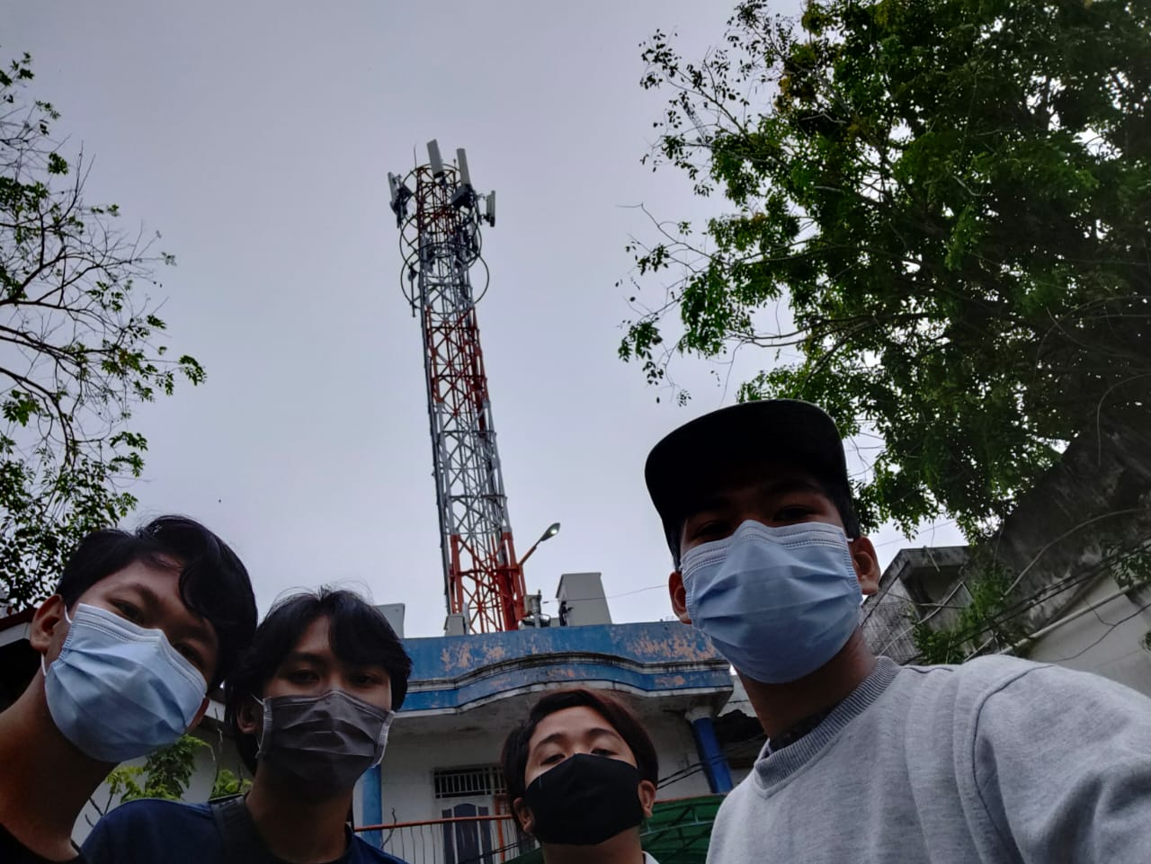

OOKLA

Network Cell Info Lite

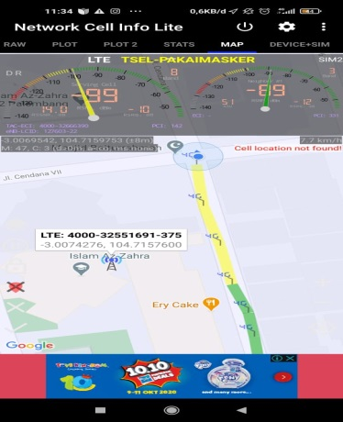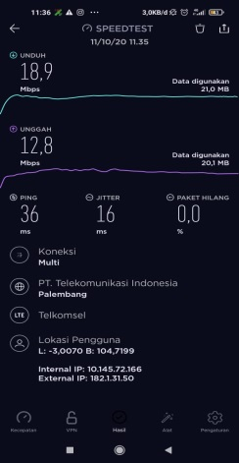

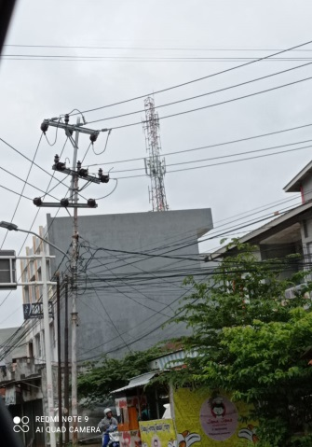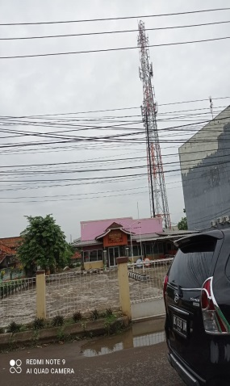

**Service Cell**: Signal strength of the cell you are currently connected too

**Frequency**: Measure the number of oscilition for the data signal per sec.In this case,only WIFI can get the frequency

**Strength of signal**:Signal strength refer to the transmitter power output as received by a reference antenna at a distance from the transmitting antenna.

**Speedtest**: Measure the **speed** between your device and a **test** server,using your device’s internet connection

**Ping**: Is available on every operating system’s,and many online games display a visible ping you can use to understand latency

Demang

Angkatan 45

|  |  |  |  |  |  |
| --- | --- | --- | --- | --- | --- |
| Location | Provider | Strength | Speed | Frequency | Ping |
| Poligon | Telkomsel | -99 dBm | 18,9 | - | 36 ms |
| Ang.45 | Telkomsel | -108 dBm | 26,6 | - | 18 ms |
| Poligon | Telkomsel | -80 dBm | 22,3 | - | 20 ms |

**Conclusion :**

**The Conclusion is that in some places,there are more Telkomsel towers than other providers.therefore the signal and the internet speed strength is faster than other providers**